INSTRUCTIONS FOR USING THIS SAMPLE FLIGHT MANUAL SUPPLEMENT

For those installations not installed in accordance with GTN 6XX/7XX AML STC SA02019SE-D, a flight manual supplement may be created using this document as a guideline. Variations to the configurations recommended in this document, including external switches and annunciators, must be approved by the FAA on an individual basis.

This Sample AFMS is intended for use with GTN 6XX/7XX software version 3.00 or later where GPS functions are not approved for IFR navigation.

- These instructions are for reference only and should not be included as part of the flight manual supplement. The text that must be checked or edited for every installation is shown in RED; other changes may be required based on your particular installation.

- The document title “Airplane Flight Manual Supplement OR Supplemental Airplane Flight Manual”. In general, Airplane Flight Manual Supplement applies to Part 23 aircraft and Supplemental Airplane Flight Manual applies to CAR 3 aircraft. Delete the one that does not apply to your aircraft and alter the footer accordingly.

- Delete section 3.2.6 if the installation is not interfaced to a heading source. Delete section 3.2.7 if the installation is not interfaced to a pressure altitude data source.

- Delete or amend Sections 1.3, 3.1.1, 3.2.3, 3.2.4, 4.1, 4.6, 7.6, 7.7, 7.8, 7.11, 7.13, 7.14, 7.15 and 7.16 as appropriate.

- Amend Sections 1.2, 7.2, 7.4, 7.5 and 7.9 according to the system installation design.

- If installation includes autopilot coupling, complete Section 4.5 according to the system limitations and operation.

- Sections that are not applicable to a particular installation must be omitted and all paragraphs re-numbered accordingly. When complete, the Table of Contents must be updated.

This Page Intentionally Blank

Installation Center
Repair Station # ________________
Name: ________________________
Address: _____________________________

AIRPLANE FLIGHT MANUAL SUPPLEMENT
or
SUPPLEMENTAL AIRPLANE FLIGHT MANUAL
for the
Garmin GTN 625, 635, 650, 725, or 750 GPS/SBAS Navigation System
as installed in

____________________________________________
Make and Model Airplane

Registration Number: ______________ Serial Number: __________________

GPS FUNCTIONS NOT APPROVED FOR IFR NAVIGATION

This document serves as an Airplane Flight Manual Supplement or as a Supplemental Airplane Flight Manual for the installation and operation of the Garmin GTN 625, 635, 650, 725, or 750 GPS/SBAS Navigation System. This document must be carried in the airplane at all times when the Garmin GTN navigation system is installed in accordance with ________________________.

The information contained herein supplements the information in the FAA Approved Airplane Flight Manual. For limitations, procedures, loading and performance information not contained in this document, refer to the FAA Approved Airplane Flight Manual, markings, or placards.

FAA Approved By: ______________________________

Federal Aviation Administration
City:______________________
State:_____________________

Date: _______________

LOG OF REVISIONS
 | Page
Revision Number | Date | Number | Description | FAA Approved
1 |  | All | Complete Supplement | See Page 1

Table of Contents

SECTION PAGE
Section 1. GENERAL 5
1.1 Garmin GTN Navigators 5
1.2 System Capabilities 7
1.3 Electronic Flight Bag 7
1.4 Definitions 7
Section 2. LIMITATIONS 9
2.1 Cockpit Reference Guide 9
2.2 Kinds of Operation 9
2.3 Applicable System Software 9
2.4 SD Card 9
2.5 Ground Operations 9
2.6 Terrain Proximity Function (All Units) 10
2.7 TAWS Function (Optional) 10
2.8 Datalinked Weather Display (Optional) 11
2.9 Traffic Display (Optional) 11
2.10 StormScope® Display (Optional) 11
2.11 Flight Planner/Calculator Functions 12
2.12 Glove Use / Covered Fingers 12
2.13 Demo Mode 12
2.14 Active Weather Radar 12
2.15 Telephone Audio 12
Section 3. EMERGENCY PROCEDURES 13
3.1 Emergency Procedures 13
3.2 Abnormal Procedures 14
Section 4. NORMAL PROCEDURES 16
4.1 Unit Power On 16
4.2 Before Takeoff 16
4.3 HSI and EHSI Operation 17
4.4 Autopilot Operation 17
4.5 Coupling the Autopilot during approaches 18
4.6 Telephone & SMS Text (Optional) 19
Section 5. PERFORMANCE 19
Section 6. WEIGHT AND BALANCE 19
Section 7. SYSTEM DESCRIPTIONS 20
7.1 Pilot’s Guide 20
7.2 Leg Sequencing 20
7.3 Auto ILS CDI Capture 20
7.4 Activate GPS Missed Approach 20
7.5 Terrain Proximity and TAWS 21
7.6 GMA 35 Audio Panel (Optional) 21
7.7 Traffic System (Optional) 21
7.8 StormScope® (Optional) 22
7.9 Power 22
7.10 Databases 22
7.11 External Switches 23
7.12 Airspace Depiction and Alerts 24
7.13 GDL 88 ADS-B Traffic System Interface (Optional) 24
7.14 GWX 70 Weather Radar (Optional) 25
7.15 Charts (Optional) 25
7.16 Transponder Control (Optional) 25

GENERAL

Garmin GTN Navigators
The Garmin GTN navigation system is a GPS system with a Satellite Based Augmentation System (SBAS), comprised of one or more Garmin TSO-C146c GTN 625, 635, 650, 725, or 750 navigator(s) and one or more Garmin approved GPS/SBAS antenna(s).

GTN system functions are shown in Table 1.
 | GTN 625 | GTN 635 | GTN 650 | GTN 725 | GTN 750
GPS SBAS Navigation (Not approved for IFR navigation) | X | X | X | X | X
VHF Com Radio, 118.00 to 136.990, MHz, 8.33 or 25 kHz increments |  | X | X |  | X
VHF Nav Radio, 108.00 to 117.95 MHz, 50 kHz increments |  |  | X |  | X
LOC and Glideslope non-precision and precision approach guidance for Cat 1 minimums, 328.6 to 335.4 MHz tuning range |  |  | X |  | X
Moving map including topographic, terrain, aviation, and geopolitical data | X | X | X | X | X
Display of datalink weather products, SiriusXM, FIS-B, Connext ( all optional) | X | X | X | X | X
Control and display of airborne weather radar (optional) |  |  |  | X | X
Display of terminal procedures data (optional) |  |  |  | X | X
Display of traffic data, including ADS-B (optional) | X | X | X | X | X
Display of StormScope® data (optional) | X | X | X | X | X
Display of marker beacon annunciators (optional) |  |  |  | X | X
Remote audio panel control (optional) |  |  |  | X | X
Remote transponder control (optional) | X | X | X | X | X
Remote audio entertainment datalink control (optional | X | X | X | X | X
TSO-C151b Class B TAWS (optional) | X | X | X | X | X
Supplemental calculators and timers | X | X | X | X | X
Control of GSR 56 Iridium Satellite Phone and SMS Text (optional) | X | X | X | X | X
Table 1 – GTN Functions

The GPS navigation functions and optional VHF communication and navigation radio functions are operated by dedicated hard keys, a dual concentric rotary knob, or the touchscreen.

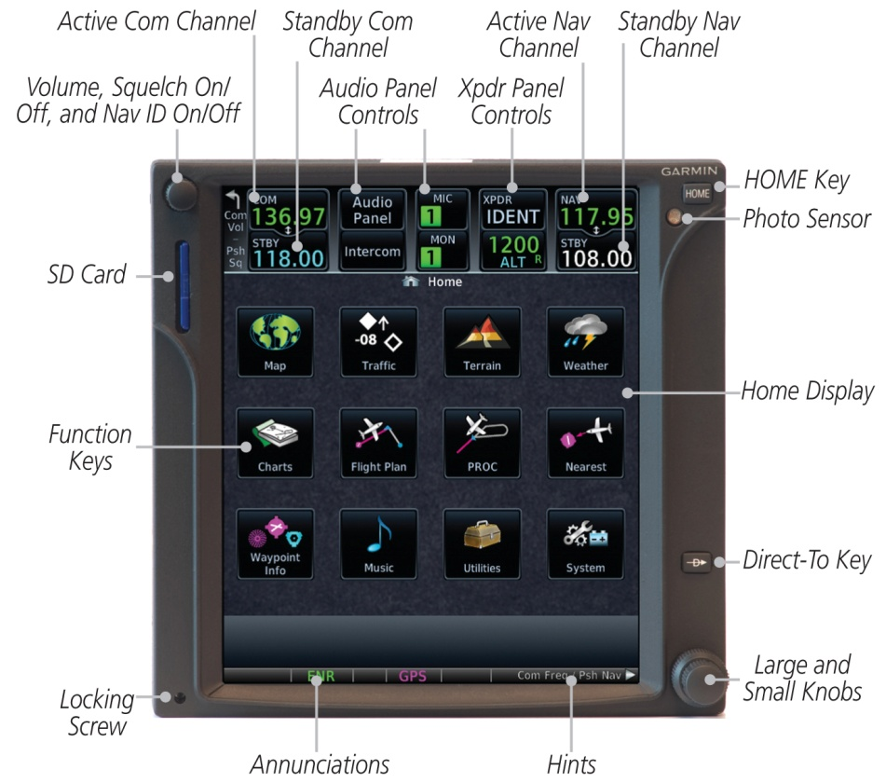
Figure 1 - GTN 750 Control and Display Layout

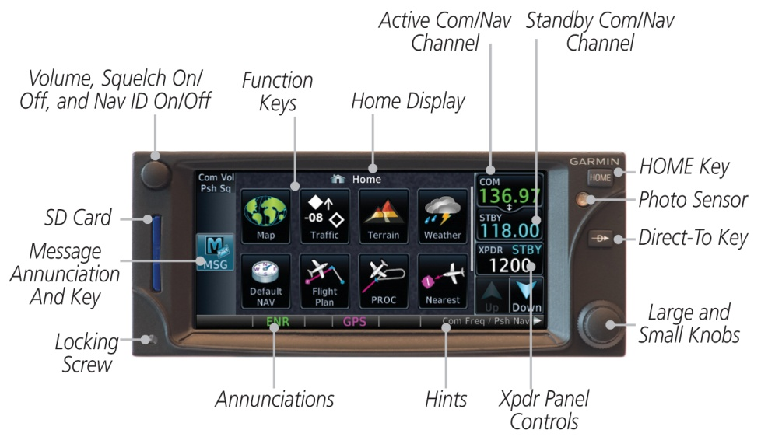
Figure 2 - GTN 635/650 Control and Display Layout

System Capabilities
The GTN system and associated navigation interface in this aircraft have the following capabilities, in addition to the core multifunction display capability:

- VHF Communication Radio
- Primary VHF Navigation
- TSO-C151b Terrain Awareness and Warning System – See section 2.7

Electronic Flight Bag
The GTN 750/725 are operationally suitable as Class 3 Hardware, Type B Software in accordance with AC 120-76B EFB electronic aeronautical information when using current FliteChart or ChartView data.

Definitions

The following terminology is used within this document:
ADF: Automatic Direction Finder
ADS-B: Automatic Dependent Surveillance Broadcast
AEG: Aircraft Evaluation Group (FAA)
APR: Approach
CDI: Course Deviation Indicator
DME: Distance Measuring Equipment
EFB: Electronic Flight Bag
EHSI: Electronic Horizontal Situation Indicator
FIS-B: Flight Information Services Broadcast
GNSS: Global Navigation Satellite System
GPS: Global Positioning System
GPSS: GPS Roll Steering
GTN: Garmin Touchscreen Navigator
HSI: Horizontal Situation Indicator
IAP: Instrument Approach Procedure
IFR: Instrument Flight Rules
ILS: Instrument Landing System
IMC: Instrument Meteorological Conditions
LDA: Localizer Directional Aid
LNAV: Lateral Navigation
LNAV+V: Lateral Navigation with advisory Vertical Guidance
L/VNAV: Lateral/Vertical Navigation
LOC: Localizer
LOC-BC: Localizer Backcourse
LP: Localizer Performance
LPV: Localizer Performance with Vertical Guidance
MLS: Microwave Landing System
NOTAM: Notice to Airmen
OBS: Omnibearing Select
RAIM: Receiver Autonomous Integrity Monitoring
RMT: Remote
RNAV: Area Navigation
RNP: Required Navigational Performance
SBAS: Satellite Based Augmentation System
SD: Secure Digital
SDF: Simplified Directional Facility
SUSP: Suspend
TACAN: Tactical Air Navigation System
TAS: Traffic Awareness System
TAWS: Terrain Awareness and Warning System
TCAS: Traffic Collision Avoidance System
TFR: Temporary Flight Restriction
TIS: Traffic Information Service
VHF: Very High Frequency
VFR: Visual Flight Rules
VLOC: VOR/Localizer
VMC: Visual Meteorological Conditions
VOR: VHF Omnidirectional Range
WAAS: Wide Area Augmentation System
WFDE: WAAS Fault Data Exclusion
XFR: Transfer

LIMITATIONS

Cockpit Reference Guide
The Garmin GTN 6XX or GTN 7XX Cockpit Reference Guide, part number and revision listed below (or later revisions), must be immediately available to the flight crew whenever navigation is predicated on the use of the GTN.

- GTN 6XX Cockpit Reference Guide P/N 190-01004-04 Rev C
- GTN 7XX Cockpit Reference Guide P/N 190-01007-04 Rev C

Kinds of Operation
This AFM supplement does not grant approval for IFR operations to aircraft limited to VFR operations.

The GPS navigation capability of this unit cannot be used as primary navigation for IFR operations.

This system is placarded in close proximity to the GTN: “GPS LIMITED TO VFR USE ONLY”.

Applicable System Software
This AFMS/AFM is applicable to the software versions shown in Table 2.

The Main and GPS software versions are displayed on the start-up page immediately after power-on. All software versions displayed in Table 2 can be viewed on the System – System Status page.

Software Item | Software Version  (or later FAA Approved versions for this STC)
Main SW Version | 3.00
GPS SW Version | 5.0
Com SW Version | 2.10
Nav SW Version | 6.02
Table 2 - Software Versions

SD Card
It is required that the SD card be present in the unit at all times.

Ground Operations
Do not use SafeTaxi or Chartview functions as the basis for ground maneuvering. SafeTaxi and Chartview functions do not comply with the requirements of AC 20-159 and are not qualified to be used as an airport moving map display (AMMD). SafeTaxi and Chartview are to be used by the flight crew to orient themselves on the airport surface to improve flight crew situational awareness during ground operations.

Terrain Proximity Function (All Units)
Terrain and obstacle information appears on the map and terrain display pages as red and yellow tiles or towers, and is depicted for advisory use only. Aircraft maneuvers and navigation must not be predicated upon the use of the terrain display. Terrain and obstacle information is advisory only and is not equivalent to warnings provided by TAWS.

The terrain display is intended to serve as a situational awareness tool only. By itself, it may not provide either the accuracy or the fidelity on which to base decisions and plan maneuvers to avoid terrain or obstacles.

NOTE
Terrain and TAWS are separate features and mutually exclusive. If “TAWS B” is shown on the bottom right of the dedicated terrain page, then TAWS is installed.

TAWS Function (Optional)
Flight crews are authorized to deviate from their current ATC clearance to the extent necessary to comply with TAWS warnings. Navigation must not be predicated upon the use of TAWS.

If an external TAWS annunciator panel is installed in the aircraft, this annunciator panel must be fully functional in order to use the TAWS system.

NOTE
Terrain and TAWS are separate features and mutually exclusive. If “TAWS B” is shown on the bottom right of the dedicated terrain page, then TAWS is installed.

Datalinked Weather Display (Optional)
This limitation applies to datalinked weather products from SiriusXM via a GDL 69/69A, FIS-B via a GDL 88, and Connext via a GSR 56.

Do not use data link weather information for maneuvering in, near, or around areas of hazardous weather. Information provided by data link weather products may not accurately depict current weather conditions.

Do not use the indicated data link weather product age to determine the age of the weather information shown by the data link weather product. Due to time delays inherent in gathering and processing weather data for data link transmission, the weather information shown by the data link weather product may be significantly older than the indicated weather product age.

Do not rely solely upon data link services to provide Temporary Flight Restriction (TFR) or Notice to Airmen (NOTAM) information. Not all TFRs and NOTAMS can be depicted on the GTN.

Traffic Display (Optional)
Traffic may be displayed on the GTN when connected to an approved optional TCAS I, TAS, TIS, or ADS-B traffic device. These systems are capable of providing traffic monitoring and alerting to the flight crew. Traffic shown on the display may or may not have traffic alerting available. The display of traffic is an aid to visual acquisition and may not be utilized for aircraft maneuvering.

StormScope® Display (Optional)
StormScope® lightning information displayed by the GTN is limited to supplemental use only. The use of the StormScope® lightning data on the display for hazardous weather (thunderstorm) penetration is prohibited. StormScope® lightning data on the display is intended only as an aid to enhance situational awareness of hazardous weather, not penetration. It is the flight crew’s responsibility to avoid hazardous weather using official weather data sources.

When the GTN StormScope® page is operating without a heading source, as indicated by the “HDG N/A” label at the upper right corner of the StormScope® page, strikes must be cleared after each heading change.

Flight Planner/Calculator Functions

CAUTION
When using the Density Altitude / True Airspeed / Winds page, all data must be entered into the calculator before the calculated data is used. Calculated data may not be correct prior to entering all data.

The Fuel Planning page uses Fuel on Board or Fuel Flow as received from an on board fuel totalizer, as entered by the pilot at system startup, or as entered by the pilot when on the Fuel Planning page. This is not a direct indication of actual aircraft fuel flow or fuel on board and those values are only used for the Fuel Planning page. The fuel required to destination is only a calculated and predicted value based on the data entered into the planner. It is not a direct indication of how much fuel the aircraft will have upon reaching the destination. Certain approach leg types will result in the fuel burn incorrectly calculated as zero.

Glove Use / Covered Fingers
No device may be used to cover fingers used to operate the GTN unless the Glove Qualification Procedure located in the Pilot’s Guide/Cockpit Reference Guide has been successfully completed. The Glove Qualification Procedure is specific to a pilot / glove / GTN 725, 750 or GTN 625, 635, 650 combination.

Demo Mode
Demo mode may not be used in flight under any circumstances.

Active Weather Radar
Radar is broadcasting energy while in Weather or Ground mapping modes. If the GTN 750/725 system is configured to control an airborne weather radar unit, observe all safety precautions, including:

- Do not operate in the vicinity of refueling operations.
- Do not operate while personnel are in the vicinity (approximately 20 feet) of the radar sweep area.
CAUTION
If a radar system is installed, it generates microwave radiation and improper use, or exposure, may cause serious bodily injury. Do not operate the radar equipment until you have read and carefully followed the safety precautions and instructions in the weather radar user manual and/or pilot’s guide.

Telephone Audio
Telephone audio may not be distributed to the pilot or co-pilot unless a phone call is active.

EMERGENCY PROCEDURES

Emergency Procedures

TAWS WARNING

Red annunciator and aural “PULL UP”:
Autopilot DISCONNECT
Aircraft Controls INITIATE MAXIMUM POWER CLIMB
Airspeed BEST ANGLE OF CLIMB SPEED

After Warning Ceases:
Power MAXIMUM CONTINUOUS
Altitude CLIMB AND MAINTAIN SAFE ALTITUDE
Advise ATC of Altitude Deviation, if appropriate.

NOTE
Only vertical maneuvers are recommended, unless either operating in visual meteorological conditions (VMC), or the flight crew determines, based on all available information, that turning in addition to the vertical escape maneuver is the safest course of action, or both.

Abnormal Procedures

LOSS OF COM RADIO TUNING FUNCTIONS

If alternate COM is available:
Communications USE ALTERNATE COM

If no alternate COM is available:
COM RMT XFR key (if installed) PRESS AND HOLD FOR 2 SECONDS

NOTE
This procedure will tune the active COM radio the emergency frequency 121.5, regardless of what frequency is displayed on the GTN. Certain failures of the tuning system will automatically tune 121.5 without flight crew action.

LOSS OF AUDIO PANEL FUNCTIONS (GMA 35 Only)
Audio Panel Circuit Breaker PULL

NOTE
This procedure will force the audio panel into fail safe mode which provides only the pilot with communications and only on a single COM radio. If any non GTN 750 COM is installed, communication will be only on that radio. If only a GTN 750 is installed in the aircraft, then the pilot will have only the GTN 750 COM available. No other audio panel functions including the crew and passenger intercom will function.

TAWS CAUTION (Terrain or Obstacle Ahead, Sink Rate, Don’t Sink)
When a TAWS CAUTION occurs, take corrective action until the alert ceases. Stop descending or initiate either a climb or a turn, or both as necessary, based on analysis of all available instruments and information.

TAWS INHIBIT
The TAWS Forward Looking Terrain Avoidance (FLTA) and Premature Descent Alerts (PDA) functions may be inhibited to prevent alerting, if desired. Refer to GTN Cockpit Reference Guide for additional information.

To Inhibit TAWS:
Home Hardkey PRESS
Terrain Button PRESS
Menu Button PRESS
TAWS Inhibit Button PRESS TO ACTIVATE

TER N/A and TER FAIL
If the amber TER N/A or TER FAIL status annunciator is displayed, the system will no longer provide TAWS alerting or display relative terrain and obstacle elevations. The crew must maintain compliance with procedures that ensure minimum terrain and obstacle separation.

DATA SOURCE - HEADING SOURCE INOPERATIVE OR CONNECTION TO GTN LOST MESSAGE
Without a heading source to the GTN, the following features will not operate:
- GPSS will not be provided to the autopilot for heading legs. The autopilot must be placed in HDG mode for heading legs.
- Map cannot be oriented to Heading Up.
- All overlaying traffic data from a TAS/TCAS I or GDL 88 interfaced to an on board traffic system on the main map display. The flight crew must use the dedicated traffic page on the GTN system to display TAS/TCAS I or GDL 88 traffic data.
- All overlaying StormScope® data on the main map display. The flight crew must use the dedicated StormScope® page on the GTN system to display StormScope® data.

StormScope® must be operated in accordance with Section 7.8 when no heading is available.

DATA SOURCE – PRESSURE ALTITUDE SOURCE INOPERATIVE OR CONNECTION TO GTN LOST MESSAGE
Without a barometric altitude source to the GTN, the following features will not operate:
- Automatic leg sequencing of legs requiring an altitude source. The flight crew must manually sequence altitude legs, as prompted by the system.

UNRECOVERABLE LOSS OF ALL ELECTRICAL GENERATORS OR ALTERNATORS
Remove power from all equipment which is not necessary for flight, including GTN #2 if installed.

NORMAL PROCEDURES
Refer to the Cockpit Reference Guide defined in Section 2.1 of this document or the Pilot’s Guide defined in Section 7.1 for normal operating procedures and a complete list of system messages and associated flight crew actions. This includes all GPS operations, VHF communication and navigation, traffic, data linked weather, StormScope®, TAWS, and Multi-Function Display information.

The GTN requires a reasonable degree of familiarity to avoid becoming too engrossed at the expense of basic instrument flying in IMC and basic see-and-avoid in VMC. Garmin provides training tools with the Pilot’s Guide and PC based simulator. Pilots should take full advantage of these training tools to enhance system familiarization.

Unit Power On
Database REVIEW EFFECTIVE DATES
Self Test VERIFY OUTPUTS TO NAV INDICATORS
Self Test - TAWS Remote Annunciator:
PULL UP ILLUMINATED
TERR ILLUMINATED
TERR N/A ILLUMINATED
TERR INHB ILLUMINATED
Self Test - GPS Remote Annunciator:
VLOC ILLUMINATED
GPS ILLUMINATED

Telephone Audio, if equipped:
Pilot, Co-pilot, Passenger DEACTIVATED

Before Takeoff
System Messages and Annunciators CONSIDERED

HSI and EHSI Operation
If an HSI is used to display navigation data from the GTN the pilot should rotate the course pointer as prompted on the GTN.

If an EHSI is used to display navigation data from the GTN the course pointer may autoslew to the correct course when using GPS navigation. When using VLOC navigation the course pointer will not autoslew and must be rotated to the correct course by the pilot. For detailed information about the functionality of the EHSI system, refer to the FAA approved Flight Manual or Flight Manual Supplement for that system.

CAUTION
The pilot must verify the active course and waypoint for each flight plan leg. The pilot must verify proper course selection each time the CDI source is changed from GPS to VLOC.

Autopilot Operation
The GTN may be coupled to an optional autopilot, if installed in the aircraft, when operating as prescribed in the LIMITATIONS section of this manual.

Autopilots coupled to the GTN system in an analog (NAV) mode will follow GPS or VHF navigation guidance as they would with existing VOR receivers.

Autopilots that support GPSS or GPS Roll Steering in addition to the analog course guidance will lead course changes, fly arcing procedures, procedure turns, and holding patterns if coupled in GPSS mode.

CAUTION
The GTN cannot provide course deviation to the autopilot for heading legs. Some autopilots do not allow the use of GPSS when course deviation is not provided.

For autopilot operating instructions, refer to the FAA approved Flight Manual or Flight Manual Supplement for the autopilot.

Coupling the Autopilot during approaches

CAUTION
When the CDI source is changed on the GTN, autopilot mode may change. Confirm autopilot mode selection after CDI source change on the GTN. Refer to the FAA approved Flight Manual or Flight Manual Supplement for the autopilot.

Analog only autopilots should use APR mode for coupling to LNAV approaches. Autopilots which support digital roll steering commands (GPSS) may utilize NAV mode and take advantage of the digital tracking during LNAV only approaches.

This installation prompts the flight crew and requires the pilot to enable the approach outputs just prior to engaging the autopilot in APR mode.

To couple an approach:
Once established on the final approach course with the final approach fix as the active waypoint, the GTN will issue a flashing message indication.

Flashing Message Button PRESS
“Enable APR Output” Button PRESS

If coupled, Autopilot will revert to ROL mode at this time.

Autopilot ENGAGE APPROACH MODE

This installation supports coupling to the autopilot in approach mode once vertical guidance is available.

To couple an approach:
Once established on the final approach course with the final approach fix as the active waypoint, the GTN will enable vertical guidance.

Vertical Guidance CONFIRM AVAILABLE
Autopilot ENGAGE APPROACH MODE

The installation does not support any vertical capture or vertical tracking.

Telephone & SMS Text (Optional)
Audio from the GSR 56 Iridium datalink is routed through your aircraft’s audio panel Audio from the GSR 56 must be deactivated (turned off) unless making a phone call. The primary indication of an incoming phone call or SMS text are the visual indications on the GTN.

PERFORMANCE
No change.

WEIGHT AND BALANCE
See current weight and balance data.

SYSTEM DESCRIPTIONS

Pilot’s Guide
The Garmin GTN 6XX or GTN 7XX Pilot’s Guide, part number and revision listed below, contain additional information regarding GTN system description, control and function. The Pilot’s Guides do not need to be immediately available to the flight crew.

- GTN 6XX Pilot’s Guide P/N 190-01004-03 Rev C or later
- GTN 7XX Pilot’s Guide P/N 190-01007-03 Rev C or later

Leg Sequencing
The GTN supports all ARINC 424 leg types. Certain leg types require altitude input in order to sequence (course to altitude, for example). If a barometric corrected altitude source is not interfaced to the GTN, a popup will appear prompting the flight crew to manually sequence the leg once the altitude prescribed in the procedure is reached.

This installation has a barometric corrected altitude source. The GTN will automatically sequence altitude legs.
This installation does not have a barometric corrected altitude source. The flight crew will be prompted to manually sequence altitude legs.

Auto ILS CDI Capture
Auto ILS CDI Capture will not automatically switch from GPS to VLOC for LOC-BC or VOR approaches.

Activate GPS Missed Approach
This installation will autoswitch from VLOC to GPS when the “Activate GPS Missed Approach” button is pressed.
This installation will not autoswitch from VLOC to GPS when the “Activate GPS Missed Approach” button is pressed. The pilot must manually switch from VLOC to GPS if GPS guidance is desired after the missed approach point.

Terrain Proximity and TAWS
- The Obstacle Database has an area of coverage that includes the United States and Europe, and is updated as frequently as every 56 days.
- To avoid unwanted alerts, TAWS may be inhibited when landing at an airport that is not included in the airport database.

NOTE
The area of coverage may be modified as additional terrain data sources become available.

This installation supports Terrain Proximity. No aural or visual alerts for terrain or obstacles are provided. Terrain Proximity does not satisfy the TAWS requirement of 91.223.
This installation supports TAWS B. Aural and visual alerts will be provided. This installation does support the TAWS requirement of 91.223.

GMA 35 Audio Panel (Optional)
The GTN 725 and 750 can interface to a GMA 35 remotely mounted audio panel and marker beacon receiver. Controls for listening to various radios, activating the cabin speaker, clearance playback control, and marker beacon are accessed by pressing the “Audio Panel” button on the GTN display screen. Volume controls for the audio panel are accessed by pressing the “Intercom” button on the GTN display screen.

Traffic System (Optional)
This system is configured for the following type of traffic system. The Garmin GTN 6XX or GTN 7XX Cockpit Reference Guide or Garmin GTN 6XX or GTN 7XX Pilot’s Guide provides additional information regarding the functionality of the traffic device.

No traffic system is interfaced to the GTN.
A TAS/TCAS I traffic system is interfaced to the GTN.
A TIS traffic system is interfaced to the GTN.
A TCAD traffic system is interfaced to the GTN.
A Garmin GDL 88 ADS-B traffic system is interfaced to the GTN.
A Garmin GDL 88 ADS-B traffic system is interfaced to the GTN. The GDL 88 ADS-B traffic system is also interfaced to an on board traffic system.

StormScope® (Optional)
When optionally interfaced to a StormScope® weather detection system, the GTN may be used to display the StormScope® information. Weather information supplied by the StormScope® will be displayed on the StormScope® page of the GTN system. For detailed information about the capabilities and limitations of the StormScope® system, refer to the documentation provided with that system.

Heading Up mode:
If the GTN system is receiving valid heading information, the StormScope® page will operate in the heading up mode as indicated by the label “HDG UP” presented at the upper right corner of the display. In this mode, information provided by the StormScope® system is displayed relative to the nose of the aircraft and is automatically rotated to the correct relative position as the aircraft turns.

Heading Not Available mode:
If the GTN system is not receiving valid heading information, either because a compatible heading system is not installed, or the interfaced heading system has malfunctioned, the StormScope® page will continue to operate without a heading source and indicate “HDG N/A” in the upper right corner of the GTN display. In this mode, information provided by the StormScope® system is displayed relative to the nose of the aircraft but is not automatically rotated to the correct relative position as the aircraft turns. When operating in this mode, StormScope® strikes must be cleared after each turn the aircraft performs.

Power
- Power to the GTN is provided through a circuit breaker labeled NAV/GPS (1/2).
- Power to the optional GTN COM is provided through a circuit breaker labeled COMM (1/2)
- Power to the optional GMA 35 is powered through a circuit breaker labeled AUDIO.

Databases
Database versions and effective dates are displayed on the start-up page immediately after power-on. Database information can also be viewed on the System – System Status page.

The Obstacle Database coverage area includes the United States and Europe.

External Switches
External switches may be installed and interfaced to the GTN. These switches may be stand alone, or integrated with a TAWS or GPS annunciator. Table 3 lists the switches and function they perform:

Switch Label | Function
CDI | Toggles between GPS / VLOC sources. This switch may be part of an external annunciator panel.
COM CHAN DN | Toggles down through the preset com frequencies.
COM CHAN UP | Toggles up through the preset com frequencies.
COM RMT XFR | Transfers the com active / standby frequencies.
NAV RMT XFR | Transfers the nav active / standby frequencies.
OBS | Performs an OBS or SUSP function. This switch is part of an external annunciator panel and is placarded with the following: “Green OBS indicates OBS or SUSP mode – GTN annunciator bar indicates which is active. Push OBS button to change OBS or SUSP mode.”
OBS/SUSP | Performs an OBS or SUSP function.
TERR INHB | Toggles the TAWS Inhibit function on/off. This switch is part of an external annunciator panel. The terrain display is still presented if TAWS is Inhibited.
Table 3 – External Switches

Airspace Depiction and Alerts
The GTN aides the flight crew in avoiding certain airspaces with Smart Airspace and airspace alerts. Smart Airspace de-emphasizes depicted airspace that is not near the aircraft’s current altitude. Airspace Alerts provide a message indication to the flight crew when the aircraft’s current ground track will intercept an airspace type that has been selected for alerting.

NOTE
Smart Airspace and Airspace Alerts are separate features. Turning on/off Smart Airspace does not affect Airspace Alerts, and vice versa.

GDL 88 ADS-B Traffic System Interface (Optional)
The GDL 88 is an ADS-B traffic system that can interface to the GTN. The nose of the ownship symbol on both the GTN main map page and dedicated traffic page serves as the actual location of your aircraft. The center of the traffic target icon serves as the reported location for the target aircraft. Motion vectors for traffic may be displayed in either absolute or relative motion. The location of the traffic targets relative to the ownship are the same, regardless of the selected motion vector.

Absolute motion vectors are colored either cyan or white, depending on unit configuration. Absolute motion vectors depict the reported track of the traffic target referenced to the ground. An absolute motion vector pointed towards your ownship symbol does not necessarily mean the traffic target is getting closer to your aircraft.

Relative motion vectors are always colored green and depict the motion of the traffic target relative to your ownship symbol. The direction the traffic target is pointed may vary greatly from the motion vector and a target may be getting closer to your aircraft independent of the direction the target is pointed. A green relative motion vector pointed towards your ownship indicates that the traffic target is converging on your aircraft.

If more than one target is occupying the same area of the screen, the GTN will combine the two or more traffic targets into one traffic group. The presence of an asterisk to the left of a target indicates that traffic has been grouped. The highest priority traffic target in the group is displayed to the pilot. When applied to airborne targets the asterisk will be displayed in white or cyan depending on the traffic depiction color used in the installation. The asterisk will be brown for grouped ground targets. The asterisk will not turn amber, even if an alerted target is included in the group.

An alerted target may be placed in the same group as non-alerted targets. In this case, the alerted target will be displayed. Two alerted targets will not be placed in the same group. All alerted targets will be displayed on the screen.

Traffic targets displayed on the dedicated traffic page may be selected in order to obtain additional information about a traffic target or to view all targets in a grouped target. When a grouped target is selected, the “Next” button on the dedicated traffic page will cycle through all targets located in close proximity to where the screen has been touched.

GWX 70 Weather Radar (Optional)
The GWX 70 Weather Radar uses Doppler technology to provide advanced features to the flight crew such as turbulence detection and ground clutter suppression. These features that rely on Doppler technology are only supported by GWX 70 units that have a 12 inch antenna or lager. Turbulence detection is only supported at display ranges 40-160 nautical miles.

NOTE
Turbulence detection does not detect all turbulence, especially that which is occurring in clear air. The display of turbulence indicates the possibility of Severe or greater turbulence, as defined in the Aeronautical Information Manual.

Charts (Optional)
The GTN 750/725 can display both procedure charts and weather data on the main map page at the same time. When datalinked Nexrad or Precipitation is overlaid on the main map page, the weather data is displayed below an overlaid procedure chart. When airborne weather radar is overlaid on the main map page, the radar data is displayed above an overlaid procedure chart.

Transponder Control (Optional)
The GTN can be interfaced to a Garmin transponder for control and display of squawk code, mode, and additional transponder functions. The activation of the “Enable ES” button on the transponder page does not indicate the aircraft is in full compliance with an ADS-B Out solution in accordance with TSO-C166b (1090ES). Consult your transponder documentation for additional information.

